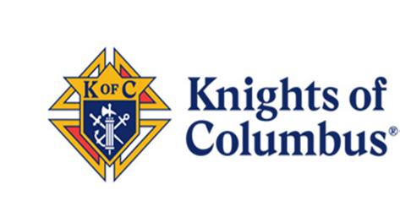
BUILDING THE DOMESTIC CHURCH KIOSK
As you enter the church you will find a kiosk containing 15 booklets provided, free of charge, by Council 6074. The Knights of Columbus are pleased to provide the rich, faith-based literature found in the Catholic Information Service (CIS) Building the Domestic Church series of booklets. Since 1948, CIS has been the major evangelical arm of the Knights of Columbus. You can take one, or two, or more booklets home with you and keep them at home making them part of your own journey of faith.

